**Review of Lab 2 Last Exercise**

The program:  
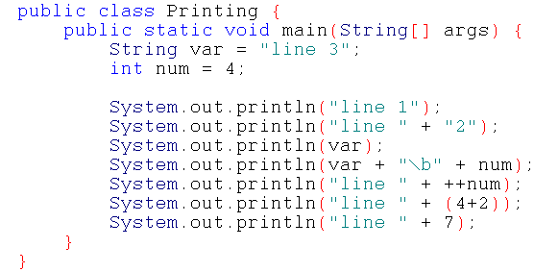

1) What is the output for this program?:  
line 1  
line 2  
line 3  
line 4  
line 5  
line 6  
line 7  
  
2) For each printline, name the type for each part: literal or variable  
a. literal  
b. literal + literal  
c. variable  
d. variable + literal + variable  
e. literal + variable  
f. literal + literal expression OR literal + literal + literal  
g. literal + literal  
Writing whether its a String or int is fine too:  
a) String literal b) two String literals c) String variable d) String variable, String literal, int variable e) String literal, int variable f) String literal, int literals g) String literal, int literal   
  
3) For the second-to-last printout are the brackets around 4+2 necessary?:  
Yes  
Why? :  
If you want to print 6 and not 42, the addition must happen to the ints before they are concatenated into a String type. The brackets trump the plus sign for order of operations.  
  
Take them out and see what happens:  
line 42  
is printed  
  
4) How could you use a post-increment instead of a pre-increment to print out the same output?:  
Put a ++ after num in the fourth println and take out the pre-increment in the fifth, like so:  
System.out.println(var + "\b" + num++);  
System.out.println("line " + num);  
OR  
insert the post increment between the lines:  
System.out.println(var + "\b" + num);  
num++;  
System.out.println("line " + num);